**Overview**

**Background**

One of my strong beliefs when it comes to hockey is that we have a lot to learn about the underlying fabric of the game. How each piece of the puzzle fits together, influences and interacts with each other, and the overall connections between things that we traditionally think of as unconnected. While I think that most of the undiscovered knowledge when it comes to underlying connections in hockey probably has to do with subjects that we haven’t even thought to examine yet, there are areas where we think that connections exist but, to my knowledge, haven’t been looked into yet. Chemistry between players is one of these areas.

The way that players fit together, elevate or restrain one another, is extremely relevant from a team building perspective. This could help us explain some of the unexplained variance in team performance relative to player talent. Of course, the idea of on-ice chemistry may be something that doesn’t exist in regards to the players skills profile. Maybe how well players play with each other is a far more individual and psychological phenomenon. Maybe underlying cognitive similarities between players, something that influences a players timing and spatial awareness, is more relevant to players chemistry with each other. These other potential explanations are far beyond the scope of this analysis, and of my expertise, so from our perspective we will only take into account the players on-ice profile.

**Method**

Without getting into too many details about the specifics (that can be found in the code and in the “Quantifying Chemistry - Explanation on Decisions”), the basic idea was to take ten years worth of player data (forwards only), and use a machine learning algorithm to cluster every player into five different clusters. Once each cluster was determined, I examined the players in them and their average stats to try and label them with hockey terms. It would be fine to just leave them as “Cluster 0”, “Cluster 1”, etc., but I think it is more informative to try and figure out what those clusters are in hockey terms, which can make understanding the results more intuitive and makes it easier to communicate to others. Once the clusters were set, I looked at every combination of forwards who have played more than 60 minutes together in a season over the last ten years, and averaged out each cluster's performance when they played with any other cluster. Then I was able to see how much better each cluster performed when they played with any other cluster, relative to their average performance. The “relative to average performance” part is important, because we are not looking at how good each cluster is, just how much better or worse each cluster plays when with another cluster, relative to their baseline play.

One major limitation of this study is that it does not include very many micro stats. Recreating this with more granular data would make this exercise far more useful, because they are way better at defining the type of player than any other kind of datapoint. In this study, the type of player is far more relevant than the efficacy of that player, so using more granular data would be extremely beneficial in this case.

**Breaking Down Each Cluster**

One quick thing to note is that players were usually in the same cluster for every season they played, which is obviously a good sign for the efficacy of the clustering. The model did not see the players name or any information that would differentiate themself from other players other than their on ice results, so the fact that players usually ended up in the same cluster in every season they played in is a good sign that the clustering accurately identified unique player types. There are over 3000 player seasons, so I won’t list them all, but for example Connor McDavid was identified as a cluster 0 in every season of his career. It should also be noted that just by looking at the players in each cluster and drawing on my knowledge of the NHL, the players in each cluster are generally very similar.

However, while I am happy with how the clusters turned out, not every player is in the same cluster that you would expect them to be in, and players are not always in the same tier every season. I do think that this gives us some insight and some approximation for player chemistry, but it is by no means a perfect system.

**Cluster 0: The Dominant Offense, No Defense Players (AllOff_NoDef)**

Defining Qualities:

* The highest A1/60, A2/60, and Points/60 of all clusters by far
* Second highest G/60
* Highest on ice xGF/60, and among the top in most offensive categories
* The worst defensive GAR and worst on ice xGA/60 of any cluster

Player Examples: Connor McDavid, Sidney Crosby, Evgeni Malkin, Leon Draisaitl, Patrick Kane

**Cluster 1: The Well Rounded Players (Well_Rounded)**

Defining Qualities:

* They are middle of the pack in almost every single category
* No clear strengths or weaknesses

Player Examples: Derick Brassard, Jordan Staal, Mikael Granlund, Ryan Nugent-Hopkins

**Cluster 2: Opportunistic Offense with a Solid Overall Game (Opportunistic)**

Defining Qualities:

* By far the highest shooting % and shooting % over expected
* Lowest shot volume among all clusters
* Solid playmaking and defensive play

Player Examples: Brock Boeser, Mikko Rantanen, Mats Zuccarello, David Perron

**Cluster 3: The Grinders (Grinders)**

Defining Qualities:

* By far the highest blocked shots, hits, and hits taken per 60 minutes of any cluster
* The best defensive results by any cluster, using expected even strength defensive GAR per 60 minutes and on ice xGA per 60
* Lowest point totals and on ice xGF/60 of all clusters

Player Examples: Andrew Shaw, Cal Clutterbuck, Ryan Kesler, David Backes, Marcus Foligno

**Cluster 4: The Shot Generators (Shot_Generators)**

Defining Qualities:

* By far the highest shot attempts and individual expected goals generated per 60 minutes
* Second highest points and on ice xGF per 60
* Average shooting talent and close to average in most other categories

Player Examples: Alex Ovechkin, Brendan Gallagher, Cam Atkinson, Max Pacioretty

**Takeaways**

For this analysis, we will look at player chemistry from an all around, offensive, and defensive perspective. There is tons of information in the graphs below, so I won’t touch on all takeaways, but I’ll highlight what I think are the most relevant things to take from them.

**Overall Chemistry**

*xGF% Table: The numbers in the table represent the % above or below the clusters xGF% average that they have when playing with another cluster. For example, 0.8 means they were 0.8% better in xGF% when playing with the listed other cluster.*

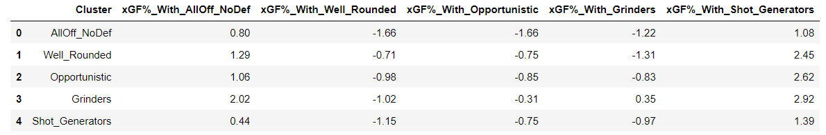

The first major takeaway is that every single player type benefits from having an offensive play driver on their line (all offense no defense cluster and shot generator cluster). This is unsurprising given that the talent in those clusters is higher, so naturally higher talent means better results, but it is still relevant because it shows the importance of players who can generate offense. What is interesting about this is that both the all offense and no defense player type and the shot generator player type get even better when playing with themselves or each other. This might indicate that instead of trying to cover up their defensive weaknesses with defensive players, it is better to just load these lines up with more firepower so they can dominate the puck even more.

However, while they are the only player types who can elevate themselves above average, they are able to elevate other player types way more than they can elevate themselves or each other. The two offensive play driving player types get a bit worse when playing with grinders, but the grinders get much better. The improvement that the grinders see outweighs the decline that the offensive players see. This information is in line with the perspective of spacing your offensive players throughout a lineup to elevate other player types, which will likely lower their offensive outputs but elevate the teams overall performance. All of this makes sense as there should be diminishing returns when it comes to on-puck value from players on the same line, because there is only one puck to go around. The best way to maximize an offense might be to space offensive play driving throughout the entirety of the lineup.

**Offensive Chemistry**

*xGF/60 Table: The number represents how many more or fewer expected goals per 60 minutes the cluster generated when playing with the other cluster. For example, -0.2 would mean that they score 0.2 xGF/60 fewer when playing with this other cluster than their average.*

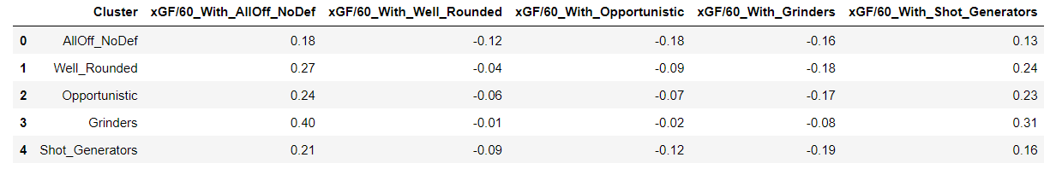

Now shifting focus to purely offensive outputs, we see similarly expected results. All player types benefit greatly on offense from having an offensive play driver on their line. Building on the point made in the previous table, grinders see massive improvements offensively when playing with one of the two offensive play driver player types. In fact, the two biggest changes in a clusters performance is when a grinder plays with an all offense no defense player, and then when a grinder plays with a shot generator. A team is extremely unlikely to win minutes when playing a line with a grinder and no offensive play driver. It might be smart, if you have good grinders that can add real value down the lineup, to target lower level offensive play drivers to pair with them because that could potentially be a good formula for extracting value out of a bottom six.

One other thing to note is that it is very possible there is more chemistry between opportunistic players and the offensive play drivers than is demonstrated in this table. This is because we are using xG in this analysis, and a hallmark of the opportunistic players game is that they capitalize on their chances, so that would not show up in these results.

**Defensive Chemistry**

*xGA/60 Table: Similar to xGF/60. A POSITIVE number is BAD, it means they allowed that many more expected goals per 60 than average when together. For example, 0.5 means that they allowed 0.5 expected goals more per 60 minutes when playing with the other cluster.*

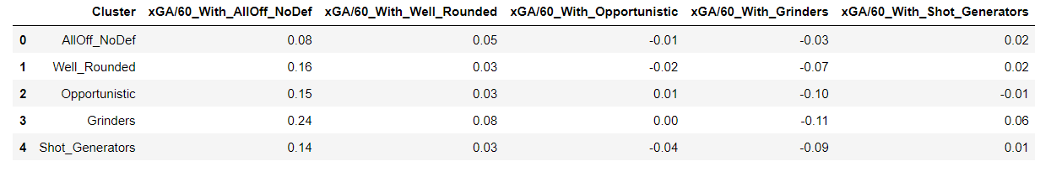

Again, we get results that are mostly expected. Grinders make every player type better on defense, and the all offense no defense player type makes everyone worse on that end. The biggest thing is that grinders have the biggest positive influence on the defensive end when playing with another grinder. This plays into some old research I did which suggested that the weakest defensive link on the ice was the most important piece, so compounding strong defensive players together may create a better defense than the sum of their parts. This also plays into what I said previously, which is that a potentially effective bottom six line could consist of two strong defensive grinders and one shot creator who is at least competent on defense. That type of line could win lots of low event minutes against other bottom lines, or could potentially even hold their own against strong top lines by creating low event hockey which would then allow your top offensive players to dominate against worse lines.

**High Level Takeaways**

There are several major, high level takeaways from this analysis. One is something that has been mentioned a couple of times, which is that players who can’t create their own shots benefit massively from playing with players who can create shots. What is significant about this is that it seems as though offensive drivers positively influence the offense of more defensively focused players more than the other way around. In other words, shot creators have a bigger offensive impact on grinders than grinders have defensive impact on shot creators. We have known for some time that forwards can control their teams offense when they are on the ice far more than they can control their teams defense, and now we know that remains true when looking at the interactions between teammates. High end offensive players don’t just have a higher offensive impact than defensive forwards have defensive impact, they also have more ability to improve their teammates offense than defensive minded players have the ability to improve their teammates defense.

This makes lots of sense when we think about the nature of offense versus defense. It is rare that players hold onto the puck for more than a couple seconds at a time. A successful offense must efficiently flow through every player, helping create space and angles for each other. Offense is far more connected than defense, literally though connecting on passes and anticipating movement. On defense, while everyone's movements are interconnected, every individual player has a role on the defensive side of the puck. The defense does not get to dictate where the puck goes, so it is more about everyone doing their job individually, whereas on offense it is about everyone doing their job together. On offense, there is one puck and everyone's actions are in relation to moving that one object to a better space. On defense, there are five assignments and everyone’s actions are in relation to their individual assignment, not the collective moving of the puck. Of course, defense is still somewhat interconnected and movements do influence each other, but to a lesser degree than offense.

The other high level takeaway is that, in the context of this specific analysis, it does not seem as though chemistry exists. I want to be very careful here because a pet peeve of mine is when people draw universal conclusions to limited analysis, but within the scope of this analysis it does not seem like chemistry is a real phenomenon. What I mean by that is that in almost every case, one player type helped another player type in a certain way, but they did not make each other better. Good offensive players help the offense of bad offensive players, good defensive players help the defense of bad defensive players, and so on. But there aren’t two player types which elevate each other beyond what you could have just assumed based on their obvious value. Going into this I thought that maybe a grinder, for example, could even help the offense of a shot creator because they create space down low and can force the defenseman to have their eyes in more directions. But relationships like that were not found in this study, and while I do think it is extremely possible that they exist and could be found using different methods, it could also be the case that line of thinking is simply over complicating a relatively simple connection between player types.

The lack of true findings on chemistry does not take away from the actual takeaways here though. A description of the findings might be how to “maximize lineup capabilities”, as we did discover real changes in player performance based on who they are playing with which can help optimize a lineup. It’s just that it doesn’t seem like two player types fit together perfectly in a way that elevates them both, instead players elevate each other as expected based on their skill set.

**Future Research**

This analysis is only scratching the surface of what could be looked into under the “chemistry” umbrella. Below are different ways to gain a deeper understanding of this area of hockey.

Different Areas to Explore under Chemistry:

* Looking at full line combinations instead of player pairs
* Looking at defenseman
* Looking at full 5 man units on the ice
* Looking at how chemistry changes given different game states (e.g. the power play)
* Going beyond just expected goals metrics to study the same ideas

Ways to get a Deeper Understanding of Chemistry:

* Looking at how the amount of time that players play together can influence chemistry
* Looking at whether player chemistry changes in the playoffs
* Doing a deep film study to try and answer the “why” of chemistry
* Looking at whether a players true position influences chemistry

Applicable Tools that Could be Built from this Analysis:

* After doing more research on player chemistry, you could build a model which predicts how well any given line would play together by using the player type and player calibre (a WAR like metric), essentially using the calibre of the players on the line in conjunction with how well those players fit together
  + Could be a useful tool for coaches when thinking about tinkering with the lines, or for management when thinking about how potential acquisitions would fit into the team